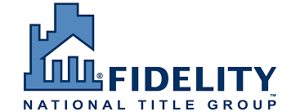
Fidelity National Title Insurance Company
Presents a Continuing Legal Education Seminar
On Wednesday, June 25th, 2025
1 CLE Professional Practice Credit Hours
“I.R.C. §1031 Exchanges and Advanced Issues”
Speakers:
Marie C. Flavin, Esq. and Ryan Vassar, Esq.
Investment Property Exchange Services, Inc. (IPX1031)
To Be Held Via Zoom Conference
Zoom Link to Be Sent Prior to Webinar
CLE Program
Time: 2:00pm – 3:00pm
By Invitation Only – RSVP here:
www.ipx1031.com/rv
This program is appropriate for both newly admitted attorneys and experienced attorneys. This program has been approved in accordance with the requirements of the NYS Continuing Legal Education Board for a maximum of 1 Area of Professional Practice. Regulations and guidelines of the CLE Board provide that credit shall be awarded only for attendance at an entire course. No credit shall be awarded for attending a portion of a course. This Program Is Being Given Without Charge. FNF Family of Companies – NY Agency Division Has Been Certified As an Accredited Provider By The New York State Continuing Legal Education Board.

